MUTENDE KUCHIMFYA MULENGA
CODE-ALPHA TASK 2
Tesla Stock Analysis Data Visualization Report
Introduction
This report presents a data visualization analysis of Tesla's stock price history from the year 2010 to 2024. The dataset contains 3,920 trading days together with 6 attributes including opening price, closing price, daily high, daily low and trading volume. The agenda was to transform this raw data into clear and easy to understand visuals that tell the story of Tesla's growth.
Tools Used
- Python in Google Colab
- Pandas for data manipulation
- Matplotlib and Seaborn for visualization
Visualizations
Chart 1: Price Over Time (Line Chart)
A line chart was used because stock price changes over time making a line chart the most appropriate choice. The chart reveals Tesla's explosive growth from under $5 in 2010 to a peak of over $400 in 2021 before correcting downward.
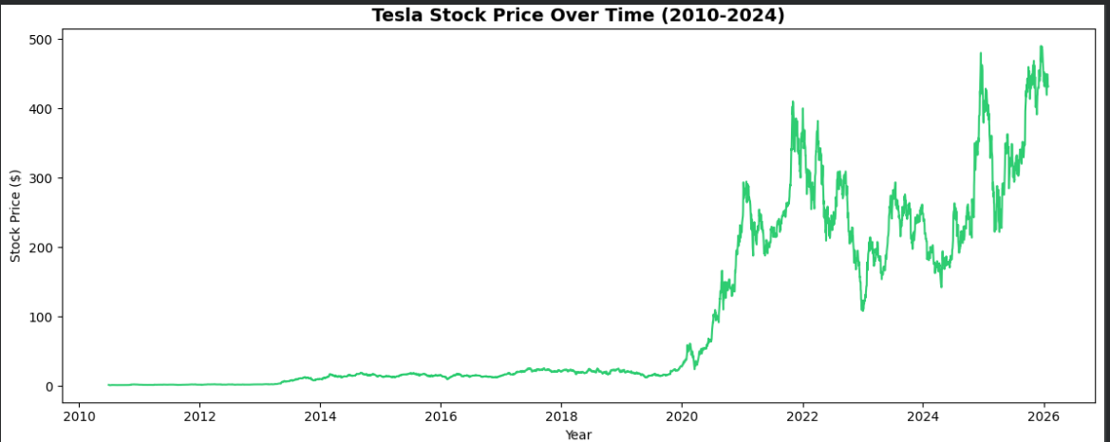
Chart 2 :Average Price Per Year (Bar Chart)
A bar chart was used to compare average prices across different years. The chart clearly shows 2021 as Tesla's strongest year with the highest average stock price.
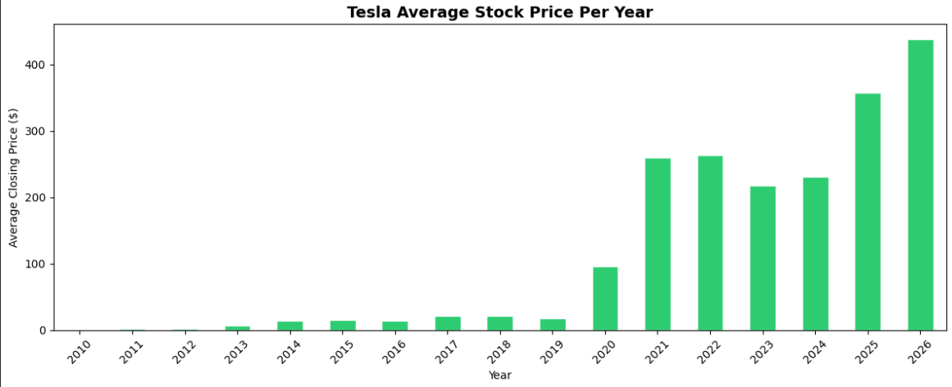
Chart 3 : Price Distribution (Histogram)
A histogram shows how Tesla's closing prices are distributed across all trading days. The chart reveals that Tesla spent most of its history trading below $100, with higher prices being less frequent.
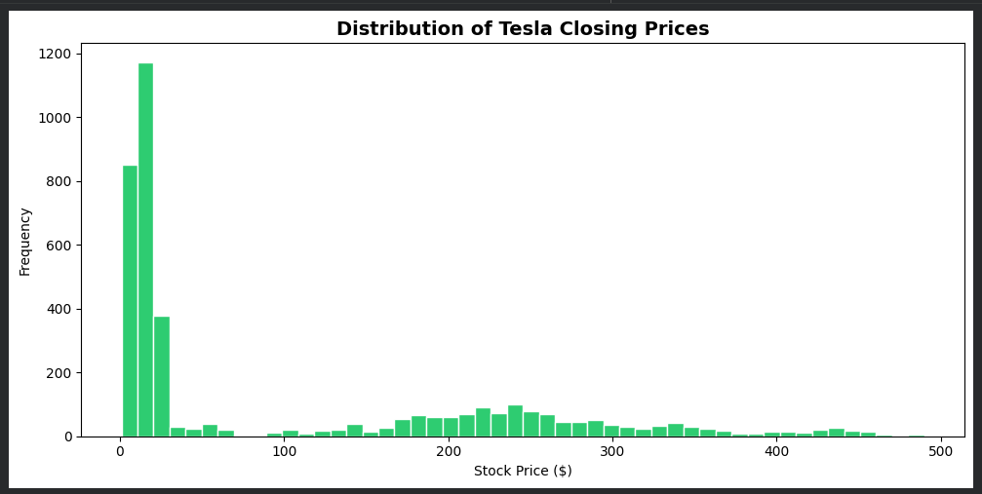
Chart 4 : Average Volume by Month (Bar Chart)
This chart shows which months see the most trading activity. Higher volume months indicate increased investor interest and market activity.
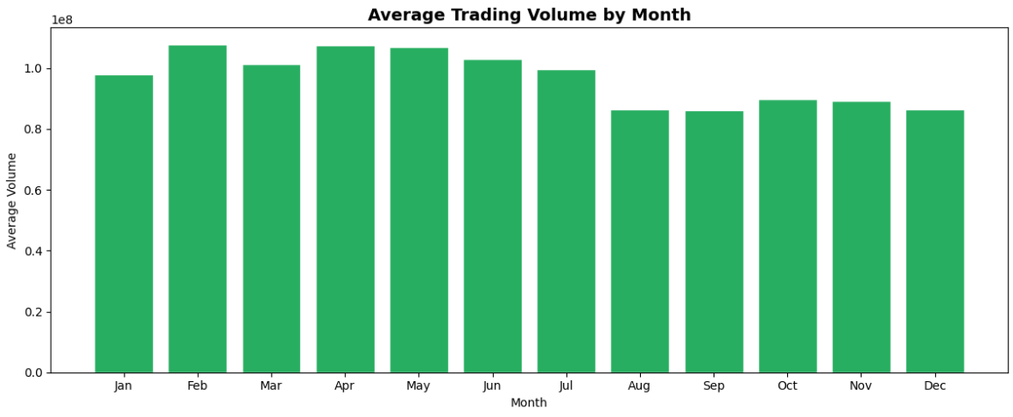
Chart 5 : Correlation Heatmap
A heatmap was used to show relationships between all stock variables. Open, Close, High and Low prices all show extremely strong correlations (above 0.99) with each other, while Volume shows a weaker relationship — meaning price movements don't necessarily mean more shares are traded.
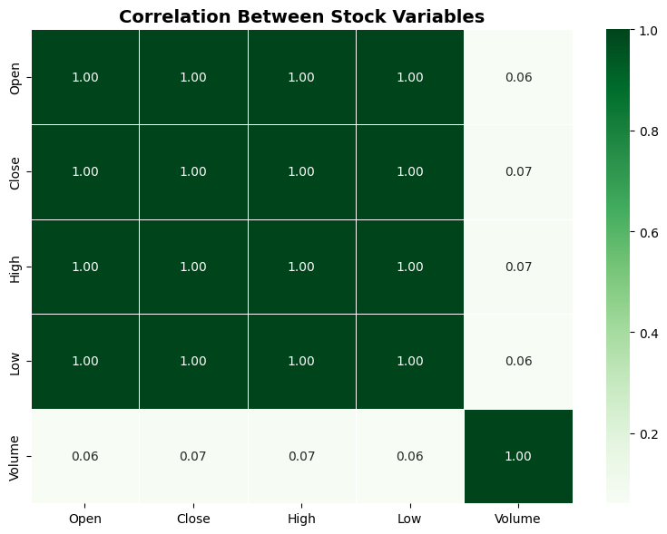
Chart 6 : Moving Averages
Moving averages smooth out daily price noise to reveal the true long term trend. The 50 day and 200 day moving averages clearly show Tesla's upward trajectory over time.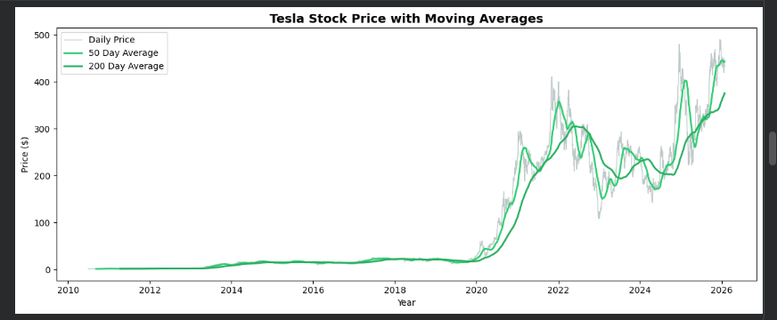

Dashboard
All 6 visualizations were combined into a single dashboard providing a complete overview of Tesla's stock performance at a glance.
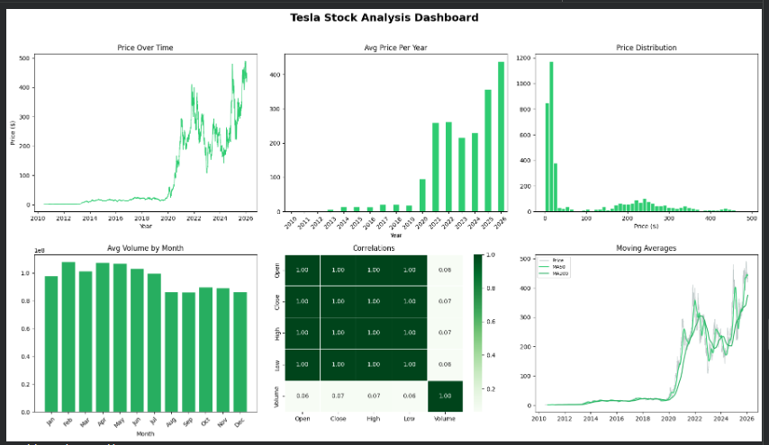
Conclusion
This analysis demonstrates how raw stock data can be transformed into compelling visual stories. Tesla's data tells a remarkable story of growth from a small trading business at under $2 per share in 2010 to one of the most valuable companies in the world by 2021.

